A Look at Writing in Two Professions

Professor Dave Howland

September 28, 2020

Technical Writing Essentials

Section 2

The purpose of this paper is to discuss writing in two expert fields – software development and teaching. Being a software developer myself, to get some guidance for the future and to understand the importance of writing, a professional in this field was interviewed. For the teaching field, the research paper includes an interview with a community college Math professor, who helped me in numerous different ways and is an integral reason for my interest in Math. Technical writing is an essential skill each employee should possess. As work environments wrestle with more tight financial plans, a representative with technical writing abilities can assist managers with saving money in different areas. Notwithstanding writing, some specialized scholars can program, create websites, and offer other specialized types of assistance to the business. They can apply critical thinking aptitudes to improve measures, convey adequately and fulfill time constraints. A technical writer is critical to a working environment as an accomplished multitasker who is prepared and conceivably affirmed in more than one territory. Eye to eye correspondence is a significant expertise in practically all positions, yet writing—regardless of whether it be messages, letters, reminders, or formal reports—can give individuals considerably more reality to impart their thoughts adequately. Not only that, in the working environment, technically written documents must be reasonable to people in general, other speculators, and even governments for chances to get an award. Funders and grant providers do not acknowledge the slang and shortened forms utilized in messages in thinking about recommendations for subsidize distribution; rather, they expect qualified candidates who can communicate obviously and persuade others regarding the advantages of their ventures.

In the pages to follow, the report emphasizes more on the importance of technical writing, especially at a workplace. Two separate segments, upheld by interviews with experts and an assortment of optional sources, will zero in on a variety of records and documents in two different fields. This incorporates a broad discussion with a senior professional software tester and a renowned award-winning math professor. A finishing up area will check out similitudes and contrasts in composed correspondence over the two fields and exercises experts have found out about what makes for good composition.

**Software Tester**

Software Testers play an integral part in application development. They are quality confirmation specialists who put applications through a lot to uncover bugs, unexpected performances, and unseen interface issues. To do this, they run a wide range of tests – stress, execution, utilitarian, versatility, client acknowledgment – at various phases of the product life cycle. Since testing is so essential to the quality and convenience of the final product, testers are regularly acquired at the arranging and configuration stage, and frequently stay required all through post-release uphold.

Most testers deal with groups that create applications available for sell. Today, a ton of programming is pushed through DevOps (advancement + tasks) groups, where improvement, testing, and conveyance are on a consistent circle utilizing the Agile, Lean, or Scrum systems. The software tester is an unrecognized yet truly great individual profession for most advancement ventures. They spare end clients from working with profoundly carriage programming or applications that simply do not function admirably and extraordinarily decreasing technical support calls from baffled clients. They additionally make the advancement group and the product seller look at great without flinching of clients by guaranteeing that there are no basic bugs that keep the product from working as planned and promoted. For the sake of this report, I had an opportunity to interview a former colleague of mine, Patricia Jones.

Patricia, an amazing software developer turned tester, is one of the most hardworking and passionate multitaskers I have worked with. Growing up in Ireland, she has always been interesting in creating new things, which is the main reason why she chose the field of Computer Programming. Being a programmer myself, I understand how stressful it can get when the deadlines are approaching or fixing an annoying bug in the software. Patricia, after many years of working as a software developer, started working as a software tester for a very well-known company in Boston. On daily basis, she works on creating and documenting automated and manual test plans and procedures, executing tests, analyzing results, and reporting on test problems and various found bugs. She also performs software testing in all phases of the software life cycle.

The main job of a software tester involves a big amount of documenting various different things. Patricia mainly creates test documents which clearly indicates the steps that are needed to perform to test the given program. Once the testing phase is done, the next step for her is to document the results and the necessary steps to be taken to fix the bugs, if any. She also mentioned that she drafts two types of documents, formal and informal. The formal document consists of all the information clearly typed, formatted, and presented by following the company’s guidelines. The informal document consists of all the information, along with additional steps or some personal remarks added by Patricia for her fellow workers to understand and go through without any problems. She mentioned that, no matter how complicated the testing steps might be, it is important for her, being the head of the department, to document everything as clearly as possible so that it is easy for everyone, especially the new recruits to understand. Along with that, she mentioned a very important thing that a good technical writer should also be able to understand the technically written work of other professionals as well. Since she is at the top-most position of her department, she spends quite a lot of time sending emails to her bosses and different clients. It is also very important for her to draft a very professionally written email to a third-party person as they could be a potential client.

She described in great detail that she might be conducting a research sometime soon in Machine Learning and explained how important it will be for her to use a formal language and follow different guidelines. The most challenging thing for her in writing is following a company specific guideline. She alluded that because she has to draft various different documents every day, and they all have different formats and sets of instructions that it gets overwhelming for her sometimes. After struggling with this a lot in the beginning, she explained that she eventually got a hold of it after drafting thousands of documents.

Writing is essential for any software tester, which is the one thing that I believe makes the job harder. Computer programmers are not very good when it comes to writing things formally, and the software testers need to master that skill as well, along with the programming abilities that are required for the job. When asked for a set of documents, she could not provide anything as it violated company’s policy, but she sent other documents that resemble the job she does. The discussion ended with her advising me to learn to describe things as clearly as possible.

**Mathematician**

A mathematician dissects information and applies numerical and statistical procedures to take care of real-world issues in business, designing, medical care, and many other different fields. They usually work with different experts to decipher mathematical information to decide or extend results and needs, regardless of whether it be theoretical or numerical. Mathematicians work in government and in private organizations to conduct research and work with usually teams of engineers, scientists, and architects to create mathematical techniques that can be used by anyone. For instance, engineers, physicists, and financial analysts use arithmetic broadly. A few workers, for example, analysts, statisticians, and researchers, are experts in a specific part of science. Despite of the really complex definition of a mathematician, simply put, they use math to solve real life problems to help different businesses. A few people with a science foundation become math educators as well. I am fortunate enough to learn more about it and interview, my Calculus-I professor Mr. Jorge Sarmiento who is a renowned mathematician and an astounding teacher. His teaching methods were remarkable and focused in learning the concepts by making sure that students think out of the box. It will not be an exaggeration to say that he is one of the smartest brains that I ever got a chance to learn from.

To give a brief introduction about him, I recall the first thing he said in class, which was, “the only way to learn mathematics is to do mathematics”, which is the truest definition of math. Math is something that one cannot just simply memorize and hope to be a master of, it is something that requires practice and dedication of years, which he explained deliberately by just that statement. Professor Jorge Sarmiento, Doctor of Arts in Mathematics, values logic. It is somewhat unexpected given that his way to instructing was guided through possibility by two nuns, 3,000 miles from his local Spain. When he came to the United States looking for job, it was an experience that in his words was “not easy” for him, but eventually, he got offered multiple internships at University of California where he conducted research and published articles in applied mathematics. Professor Sarmiento had a different way of looking at problems, and he always said to understand the questions completely which only will lead to the answers. Not only that, he indicated that he learns a great deal from his students, quoting from his website, he says, “They bring me back to reality. You cannot separate their personal lives and problems from what you are teaching. It’s important to mix the human component with the math.”

When asked about his writings, he briefly explained the type of researches he was part of. He learnt professional writing just to precisely write executive emails to his colleagues and different research organizations. According to him, he mostly writes to different universities or research organization about research related things and for funding. Having contacts with various professors of his field in different institutions, most of his emails are business related and professionally written. As mentioned earlier, him being a part of different research programs, he learnt most of technical writing from his colleagues and mentors, as it was very essential in what he was doing. To understand more about the papers, he wrote that his papers mainly focused on applied mathematics, and unfortunately, was not able to provide any of his works. He instead forwarded the course syllabus that he teaches, as it is his full-time job, and described that he worked on many of the things that are mentioned in the syllabus. That is one of the reasons why he is a brilliant teacher because he worked on each of those concepts in depth. Not only writing research papers, he also helped out to conduct numerous researches without his name attached to it. He wrote papers to understand the concept of applied mathematics in depth and provided additional proofs for already written theorems. The papers are of very high standards; hence, they work as references and are mainly used in conducting research by other professionals. He explained that scientific writing has been very important in his area of study and asserted that it is critical for every researcher to learn.

As a mathematician, he described that most of his time was spent on getting the desired results and indicated that sometimes it is not the case. After the desired criteria is met and results are proper, their team starts writing everything formally in the form of a research paper, just like every other research. When asked the most challenging part in that process, he answered with “writing everything down”. The whole point of a successful research is for everyone to understand it, and it is not easy to explain the hard work of months or years in simple language that is reasonable to everyone. Not only that, being a native Spanish speaker, he also had difficulties initially in writing and understanding everything in English. He mentioned that he was surrounded with a great group of people who helped him in each step of his life.

Being a full-time professor now, he does not get to write and publish a lot, but he keeps learning about new things and developments in his field. He said that he mostly does teaching and organizing various events related to math. He also sent me a flyer he designed for a math event which is attached at the end of this paper. When asked for advice for someone who is new in the field of teaching and mathematics, he suggested to work on building a strong foundation, especially, if the end goal is to do research in math or other respective field. He alluded that knowledge of technical writing will help in any field one desires to pursue, adding to that, he asked me to focus on clarity in any kind of writing and sticking to the point. Believing in his advice, it will be a good learning experience to practice all the good qualities mentioned by him in the talk.

**Conclusion**

The paper has discussed the importance of technical writing and how one could benefit from it. Not only that, it discussed some key points mentioned by both Professor Sarmiento and Patricia. Despite of it being very integral to a business, it is not for everyone. While everybody has examined specialized composition at once or the other, this sort of composing can be hard for certain individuals, particularly the individuals who lean toward an imaginative way to deal with composing. Specialized composing requires an emphasis on verifiable data and systems. Specialized technical writers must be able to decipher data that is here and there and is difficult to fathom into terms that individuals who are not specialists on the subject will have the option to peruse and track, without misconception. Clearness, instead of inventiveness, is the way to powerful technical writing, is the one thing both professionals advised on.

The guidance given by both the professionals is very similar. They both discussed to take an extra step in focusing and improving one’s technical writing abilities. To do so, Professor Sarmiento suggested to maybe take online classes and to go to seminars and workshops. They both indicated that the important part is to understand who the audience is. This can set the tone, length, and style of writing, as well as help in organizing the material. The other similar things taught by both the professional is that a successful writer needs to know how much to explain or not explain, in other words, clear writing. Patricia talked about having some time lapse between creation of a document and the final review that can help the writer see it with new eyes, so it can be polished to perfection before it is published. That is just one trick a tech writer should know about self-edited copy, which was also explained by Professor Sarmiento. Hereafter, we see that quality work environment writing is key to progress and requires significant investment, practice, and scrupulousness.

**Bibliography:**

[1]: Sherry, Rosie. “What Do Software Testers Do?”, Ministry of Testing, 2016, https://www.ministryoftesting.com/dojo/lessons/what-do-software-testers-do-version-0-1

[2]: Fabiano, Jennifer. “What is Software Engineering?”, Ladders, 11 November 2009, https://www.theladders.com/career-advice/what-is-software-engineering

[3]: Florea, Raluca, and Viktoria Stray. "The skills that employers look for in software testers." Software Quality Journal 27.4 (2019): 1449-1479.

[4]: Itkonen, Juha, Mika V. Mantyla, and Casper Lassenius. "How do testers do it? An exploratory study on manual testing practices." 2009 3rd International Symposium on Empirical Software Engineering and Measurement. IEEE, 2009.

[5]: Christoph, Schmidl. “How To Write Articles Like A Software Engineer”, Medium, 10 August 2020, https://towardsdatascience.com/how-to-write-articles-like-a-software-engineer-d7a1857de81

[6]: “Mathematicians - what they do”, StudentScholarships.org, 2009, https://studentscholarships.org/salary/484/mathematicians.php

[7]: Weber, Keith, and Jennifer Czocher. "On mathematicians’ disagreements on what constitutes a proof." Research in Mathematics Education 21.3 (2019): 251-270.

[8]: Stillman, Gloria, Jill Brown, and Jennifer Czocher. "Yes, mathematicians do X so students should do X, but it’s not the X you think!." ZDM (2020): 1-12.

[9]: Castaneda, Apolo, et al. "Representations of mathematicians in lower secondary mathematics textbooks." EURASIA Journal of Mathematics, Science and Technology Education 15.7 (2019): em1716.

[10]: Yan, Xiaoheng, Ofer Marmur, and Rina Zazkis. "Calculus for teachers: Perspectives and considerations of mathematicians." Canadian Journal of Science, Mathematics, and Technology Education 20.2 (2020): 10-1007.

[11]: “Jorge Sarmiento”, CCM, https://www.ccm.edu/spotlight/jorge-sarmiento/

**Appendix A: Course Syllabus Provided by Professor Jorge Sarmiento**

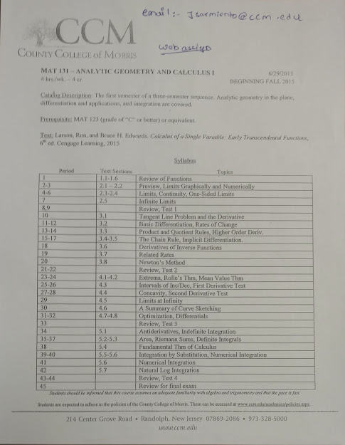

**Appendix B: Weekly Math Group Review Flyer**

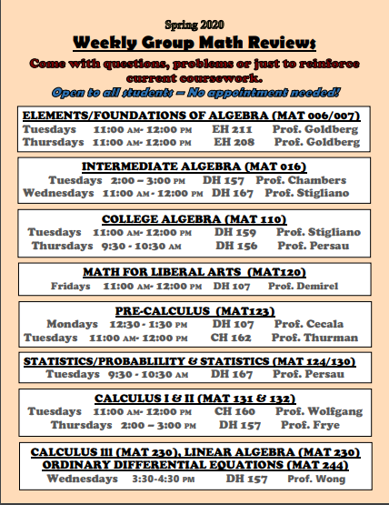

**Appendix C: Sample Testing Plan of a Software Tester**

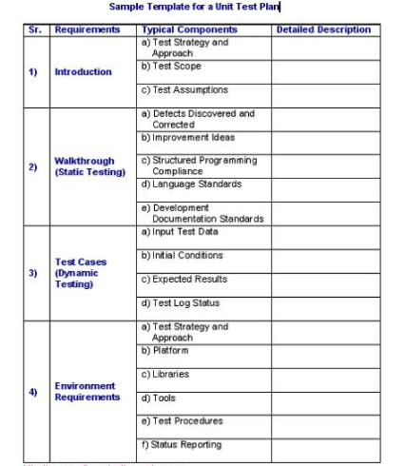

**Appendix E: Email Requesting Interview**

Professor Sarmiento,

Hope you are doing well in these adverse times.

My name is Himesh Buch, a former student of yours, at County College of Morris. Let me start off by saying that it is my pleasure to have learnt a variety of things, math being one of them, from an instructor like you. I still remember waiting for you at your office ahead of time to avoid the influx of students at office hours and ask you different questions and get very polite and respectful answers.

I am writing you today, as i understand that you have done research in applied mathematics before being a full-time professor. As part of an assignment for an English class in technical writing, I have been assigned to seek out and interview a professional about the writing they do for work. I would like to know, in particular, how important technical writing has been for you? I have put together a list of questions that i would really appreciate your feedback on,

1. Describe your job. What do you do?
2. Describe the role writing plays in your work routine. Discuss three specific documents you create on a regular basis and the audiences and purposes of these documents.
3. What percentage of your time in any given week would you estimate you spend on writing and editing tasks?
4. What is most challenging about writing for you? How do you handle these challenges?
5. How important is writing in your field? Does it matter how well you write? Why?
6. What advice would you give about writing and communication to someone new to your career?

I look forward to talking to you. I will be available Tuesday and Thursday anytime suitable to you to go over these questions. Please let me know what time works for you the best and we can schedule an interview.

I really appreciate all the efforts of yours and spending time to talk with me about it

Sincerely,

Himesh Buch

**Appendix F: Formal Thank You Letter**

Himesh Buch

57 Lipman Dr,

New Brunswick, NJ 08854

September 20, 2020

Jorge Sarmiento

County College of Morris

214 Center Grove Rd

Randolph, NJ 07869

Dear Professor Sarmiento,

Thank you very much for taking the time and talking to me about your experience and the importance of writing. I learnt a great deal from you in this interview, and it was such a pleasure to talk to you after a long time. The information that you provided was very helpful to me and will try follow your suggestions in future, as precisely as I can.

The information you provided helped me in writing a report about the importance of technical writing in different professional fields. It was great to hear from you and learn about your most recent work. Please feel free to let me know if I can be of any assist to you in future.

Once again, I really appreciate your time and effort in helping me out.

Sincerely,

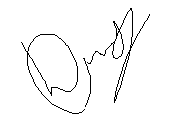

Himesh Buch